**Assignment - SWOT Analysis – Strengths and weaknesses**

Shaun Pritchard

Rasmussen College

COM3278

Jacob Johnston

August 30, 2020

**SWOT Analysis – Strengths and weaknesses**

**Analyzed strengths and weaknesses**

The proposed technological approach of using a lingua franca the use of extendable markup languages such as XML could help bridge the gap of the information conflict being experienced by this pandemic outbreak. XML can offer advantages in implementing communications services, tracking, updates, web and mobile-based portals, notifications, and communication efforts. We can implement technologies and tools that are readily available with natural language processing while having the computational speed of providing up-to-date accurate information and resources to specific locations. Also, collect data that can be inferred to save live and prevent the spread in other regions.

While lingua francas can solve communication problems among people of different linguistic backgrounds. It provides strengths are that is maintains mutual understanding between people who can communicate with each other in different languages. Also, provides access to computational resources, such as translation services, visualization, symbolic, and natural language processing data.

Some of the weaknesses of using this would be in the implementation. Allocating all the resources necessary in a fashion for the specific event has to be properly scoped, tested, and deployed. Using Information Systems, one must understand that they do not understand the complexities of language let alone multiple languages in multiple regions. We will have to work diligently to find the correct and most important aspects of the technology while building the assets we need for our particular venture to spearhead the operation.

We must also be aware that implementing technology in this fashion could lead to linguistic imperialism in the sense that one language is taken as better than the other might lead to the death of native languages especially in central Africa or being overrun due to the underestimated implementations their language lower than the language of the lingua franca. While our main concern is overcoming this virus and pandemic, we should be aware of what we are introducing in specific regions of the world and be mindful of cultural appropriation.

**Resources**

To implement this technology in an orderly fashion that could be readily available to doctor physicians and rural residence of many parts of the nation we will need to scope out and manage this project with efficiency. I propose that we build a progressive web application(PWA) using a specific web framework such as Angular Universal *(Angular, 2020)* to build from template a web application with a manifest that has integrated markup JavaScript framework that utilizes web-based HTML, CSS, JSON, and XML markup languages.

This will give us the ability to have a web-based mobile application that could be used for practitioners in areas with limited data connectivity and internet service. Also proposed that we develop an internal API(application interface) to give access to other areas to the application data and build custom web applications to further calculate data and web assets in many other native languages and environments. Also, this will give us the ability to collect rapidly collect real-time data and many of the hard to reach or limited regions.

 Using this framework with HTML based markup languages, we can implement open source dependencies and plugins that will allow us to use natural processing and translation of the page’s information. letting the users of many different regions and areas across Europe and Africa that we are concerned with obtaining the communication efforts fast and effectively.

We will essentially need to assemble a team and a budget of twenty-five thousand dollars. First, we will need a project manager to the scope and track out the project, a software architect to implement the designs and data allocation, several software engineers to build the logic of the application, front-end web & mobile UI developer to design the application, a database engineer to design the back-end of the application, and we will need several researchers to start working on the content and designs of the information will you need to use to spearhead gap the communications between all these affected areas.

The proposed web framework has XML based schema utilizing a JavaScript framework and pre-made templates ready to build that will save us an immense amount of time from having to build an entire application from scratch *(MDBootstrap, 2020)*. Also, this provided us will an application framework that can be used for either the web or mobile devices even when the user is offline(not connected to the internet). Libraries offer rich UI components that will make it simple to create Hotspot data surveillance dashboard Maps and integrated dashboard for tracking and communicating the real-time data.

We can see here is an example of a data surveillance map being used stateside in Florida incorporating the same technology *(FDH, 2020*).

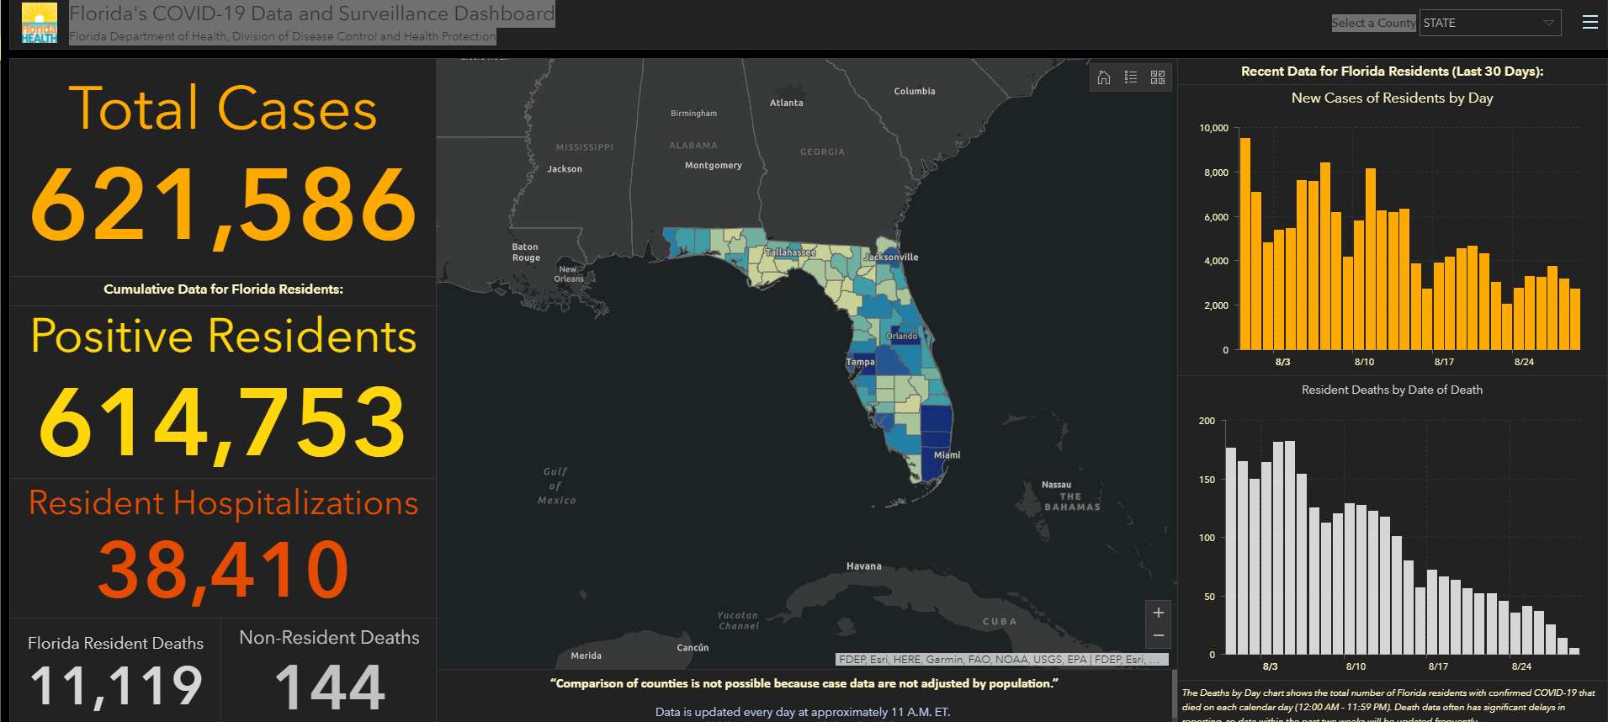

**Pros and cons**

The advantage of this proposed markup languages is the technology is adaptable to all types of devices whether it is a desktop, browser, web interface, or a mobile device. It can be utilized to do the means of an application. Simply building a website page might not be effective on a mobile device that is on a mobile device it is not connected to the internet. Using markup languages gives us the ability to transpose data different devices and different mediums a Technologies allowing us the fastest way to correlate and communicate information. Not only that but the markup language is effective in communicating with different scripting languages which allow for visualizations, collection of data, and real-time communications such as messaging and notifications. XML is the native design language for Android mobile devices what is there are 2.5 billion Android places currently active on the planet including in many of the areas of this pandemic concern *(Taylor Kerns, 2019)*.

Markup languages provide many different advantages such as low maintenance, stability, complete UI elements, many open source programs, and libraries have been written to facilitate specific needs, visualizations, robust architecture, scripting, and data allocation. Some of the disadvantages are of course the implementation learning curve, dependency of specific frameworks and libraries, and security.

**Possible issues:**

Some of the problems that I foresee initially would be scoping the project out. We can use agile methods to get the basis of the information that we need right now in the application to track virus data and communicate awareness. Getting pertinent information into the hands of Physicians and possible affected areas and regions. After we delimit the scope of the project the implementation could be an issue depending on the complexity of the scope. It could cause issues and delays with building logic inside the technology. This is why we should focus on what is important now then add what we need as we go.

Other problems could be scope creep or design conflicts what's the design and implementation, but this is why I suggested having a project manager to make sure that all team members stay within specific guidelines with a specific goal to reach. As far as the technology is concerned about implementing libraries and plug-ins for the translation of specific regions we will have to be overlooked and possibly reprogram.

We have to remember that this is computer programming, and markup languages are basic instructions from a computer that do not know specific intricacies ,voice, tone or other complexities of the human language. Due to this many natural language processors and translators might be able to translate specific words according to what they are programmed but the dialect in the syntax of real human native languages might come out wrong. Possibly confusing people who read it in different languages in rural regions *(ARIKA OKRENT, 2016)*.

**Conclusion:**

I believe this implementation could save us a lot of time and a save many lives we have many advantages such as implementing markup languages such as XML and HTML are easy to create, fast to work with, and can't communicate on all types of devices. Some of the disadvantages are this is going to take some time, some effort, and some coordination to build correctly. Also, the application resources we are implementing are not decentralized. Web pages must be edited and develop separately and strategically. In light of the current situation we are facing I believe these risks far outweigh theses minor discrepancies. It would be in our best interest to facilitate this application as quickly as possible to start breaking down the barriers holding us back from communicating with the various regions about this virus and spearheading the situation. Also, this will allow us to collect detrimental data that can be inferred and used from these regions that will give us a long-term advantage in overcoming this virus.